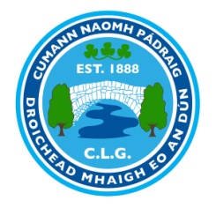
AGM NOMINATION FORM 2021
Mayobridge GAC Club’s Annual General Meeting will be held on Monday 6th December 2020 at 7.30pm.
All fully paid members are entitled to nominate (nominee must be asked), and vote. Each Nominee must be proposed and seconded by a full member
Nominations, motions and Recommendations must be returned to Tomás Ó hÍr (Rúnaí, Droichead Mhaigh Eo) on or before Monday 22nd November 2021 returns may also be sent by email to secretary.mayobridge.down@gaa.ie.
Additional Officers Maximum 10 as per Club Constitution adopted at Congress 2021
 | Nomination | Proposed | Seconded
Cathaoirleach/ Chairperson
Leas-Cathaoirleach/ Vice Chairperson
Rúnaí/ Secretary
Cisteoir/ Treasurer
Cláraitheoir/Registrar
Oifigeach Cultur agus Teanga/Officer for Irish Language and Culture
Oifigeach Caidrimh Poiblí/ P.R.O
Oifigeach na bPáistí/ Children’s Officer
Ionadaí na n-Imreoirí / Players’ Representative
Oifigí Eile/ Additional Officers
Signed:
Motions Over Page

