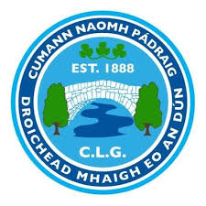
Mayobridge GAC AGM 2019/2020 Nominations

President: Tom O’Hare
Vice President: Tom O’Hare
Johnny McConville

Chairperson: Mairead Rooney
Vice Chairperson: Gerard Keenan
Secretary: Thomas O’Hare
Assistant Secretary: Ann Fitzpatrick
Treasurer: Maria Carroll
Helena Johnston
Rosemary Magee

Assistant Treasurer: Rosemary Magee
Helena Johnston

Children’s Officer: Ann Fitzpatrick
Registrar: Declan Mason
Joanne Hardy
Thomas Coulter

County Board Rep: Thomas Coulter
Paula Magee

Irish Cultural Officer: Darren Rooney
Cultural Officer: Gerard Keenan
P.R.O: Carmelita McCoy
Health & Wellbeing Officer: Sean McElroy
Coaching Officers: Eoghan Woods
Tim Colhoun

Players Rep Male: Eoghan Woods
Cathal Killen

Players Rep Female: Maria Carroll
School Liaison Officer: Sean McElroy
Additional Officers Up to 5: Sean Rooney, Pat Joe Magee, Peter O’Hare, Michael Toner, Benny Coulter, Paula Magee, Marie Sherry, Kevin McClorey, Michael Lively, Ryan Brady, Cathal Killen, Charlene Lively, Michael Goss, Cindy Griffin, Paddy Tumelity, Darren McConville

